CHAPTER ONE

INTRODUCTION

1.1 Background to the Study
The rapid advancement of information and communication technologies has led to unprecedented growth in digital data creation and storage. Individuals, academic institutions, financial organizations, healthcare providers, and government agencies increasingly rely on digital systems to store sensitive information such as personal records, financial documents, and confidential communications. While this transformation has improved efficiency and accessibility, it has also introduced serious security challenges.
As digital storage expands, cybersecurity threats have grown more sophisticated. Cybercriminal activities such as hacking, phishing, ransomware attacks, and unauthorized data access have become increasingly common. Many data breaches occur not because systems lack authentication, but because stored files are not encrypted. When attackers gain access to storage devices through malware, network intrusion, or physical theft, unencrypted files can be easily read, copied, or distributed.
Traditional protection mechanisms depend on access control methods such as usernames, passwords, or operating system permissions. While these restrict user access at the system level, they do not protect file contents themselves. If attackers bypass authentication or extract storage media, data remains exposed in readable form. This highlights the limitation of relying solely on access control without cryptographic protection.
Cryptography addresses these challenges by ensuring data confidentiality through encryption, which transforms readable plaintext into unreadable ciphertext. The Advanced Encryption Standard (AES) has emerged as the most secure and widely adopted symmetric encryption standard globally, replacing older standards due to its resistance to brute-force attacks and computational efficiency. AES supports multiple key lengths—128, 192, and 256 bits—with AES-256 offering exceptional security suitable for both enterprise systems and local applications.
This study focuses on designing and implementing a secure file storage system utilizing AES encryption to enhance data confidentiality, providing robust protection against unauthorized access in digital environments.

1.2 Statement of the Problem

Despite the increasing reliance on digital file storage systems for managing sensitive information, many existing solutions fail to provide adequate protection against modern cybersecurity threats. These weaknesses expose users to risks such as unauthorised access, data breaches, and loss of confidential information. The major problems identified in current storage practices are outlined below:

1. Plaintext storage of sensitive files
Many conventional storage systems save files in readable or unencrypted formats. In the event of device theft, hacking, or server compromise, attackers can immediately view, copy, or manipulate the contents of these files without any restriction. This lack of encryption significantly undermines data confidentiality and increases the likelihood of information misuse.

2. Weak and insufficient authentication mechanisms
Most systems rely solely on simple usernames and passwords to protect user accounts. However, weak passwords, password reuse, phishing attacks, and brute-force techniques often allow attackers to bypass authentication controls. Once access is gained, sensitive files become fully exposed, making password-only protection unreliable.

3. Lack of integrated and layered security controls
In many existing platforms, security features such as encryption, authentication, and authorization are implemented separately or inconsistently. This fragmented approach creates vulnerabilities and loopholes that attackers can exploit. Without a unified framework that combines multiple layers of protection, the overall security of stored data remains inadequate.

1.3 Aim and Objectives of the Study

Aim
This study aims to design, develop, and implement a secure file storage system that protects digital files against unauthorised access and data breaches through the integration of Advanced Encryption Standard (AES) cryptography, user authentication, and controlled access mechanisms, thereby ensuring the confidentiality, integrity, and security of stored information.
This aim emphasises not only the development of a functional storage platform but also the incorporation of strong security principles that guarantee that sensitive files remain protected even if the storage medium or server is compromised.

Objectives of the Study
To achieve the stated aim, the study will pursue the following objectives:
1. To design a comprehensive security architecture for the proposed system
The study will develop a structured system design that integrates encryption, authentication, and authorisation into a unified framework. This ensures that multiple layers of protection work together to minimise security gaps and vulnerabilities.
2. To implement AES-based encryption for protecting stored files
The system will incorporate the Advanced Encryption Standard to automatically encrypt files before they are saved to the storage medium. This ensures that even if unauthorised access occurs, the data remains unreadable and confidential.
3. To develop a secure user authentication mechanism
A robust login and verification module will be created to confirm user identities before granting access to the system. Techniques such as password hashing and salting will be applied to safeguard user credentials against theft or compromise.
4. To design a user-friendly interface that simplifies secure file operations
The application will be developed with ease of use in mind so that users can upload, store, and retrieve files securely without requiring advanced technical knowledge. Automating security processes will encourage proper adoption of protective measures.

1.4 Significance of Study
The motivation for this study arises from the increasing reliance on digital storage systems and the corresponding rise in cybersecurity threats targeting stored information. Individuals, educational institutions, businesses, and government organisations continuously generate and store sensitive data electronically. Although digital storage improves efficiency and accessibility, it also exposes information to risks such as unauthorised access, malware attacks, ransomware, insider threats, and data breaches. These threats have made data security a critical concern in modern information systems.
Recent reports of cyberattacks demonstrate that poorly protected storage systems are frequent targets because stored files often contain valuable and confidential information. When files are stored without encryption, attackers who gain access to storage devices—either physically or remotely—can easily retrieve sensitive data. The consequences of such breaches include financial loss, identity theft, service disruption, legal liabilities, and reputational damage. These realities highlight the urgent need for secure mechanisms that protect data even if storage systems are compromised.
Another motivation for this research is the observation that many individuals and small organisations continue to rely on insecure storage practices. Files are often stored on local disks or portable devices without adequate encryption. Although encryption technologies are available, they are sometimes underutilised due to complexity, limited awareness, or perceived difficulty of implementation. This creates a need for a lightweight and user-friendly system that integrates security directly into file storage operations.
From an academic perspective, this study bridges the gap between theoretical cryptography and practical system development. While encryption algorithms such as the Advanced Encryption Standard (AES) are widely studied, practical implementation experience is often limited. Designing and implementing a secure file storage system demonstrates how cryptographic principles can be applied to solve real-world security challenges.
In summary, this research is justified by the increasing prevalence of cyber threats, the weaknesses of existing storage practices, and the need for affordable yet secure solutions. The proposed system addresses these challenges by integrating AES-based encryption with authentication mechanisms to enhance data confidentiality and overall system security.
1.5 Scope of the Study
This study focuses on the design and implementation of a secure file storage system that utilizes Advanced Encryption Standard (AES) cryptography to protect user data. The system is developed as a web-based application that enables users to securely upload, store, manage, and retrieve files through an authenticated platform. The primary goal is to ensure that files remain confidential and inaccessible to unauthorized individuals through the integration of encryption and access control mechanisms.
The scope of the system covers the development of core security features, including user registration, login authentication, password hashing, file encryption, secure storage of encrypted files, and controlled decryption during authorized downloads. Each file uploaded by a user is automatically encrypted before being saved to the storage medium. Likewise, decryption is performed only when the legitimate owner requests access to the file. This ensures that sensitive data is never stored in plain or readable format on the server.
The system is implemented using Python and the Flask web framework for backend operations, SQLite for database management, and AES cryptographic algorithms for encryption. The application will run on a local machine and may also be deployed on free or small-scale hosting platforms for demonstration purposes. The system is designed primarily for small-scale usage, such as students, individuals, and small organisations that require basic yet reliable file protection.
Furthermore, the study includes system design, requirement analysis, implementation, testing, and evaluation of the security performance of the developed solution. Testing procedures will verify that encrypted files cannot be accessed without proper authentication and that the encryption process does not significantly degrade system performance.
However, the scope does not extend to large-scale enterprise storage systems, distributed cloud architectures, or high-availability infrastructures. The project is intended as a prototype and academic implementation rather than a commercial production system.

1.6 Definition of Terms
For clarity and better understanding, the following terms are defined as they apply to this study:
Advanced Encryption Standard (AES):
A symmetric-key encryption algorithm used worldwide to secure digital information by converting plaintext into ciphertext using cryptographic keys.
Encryption:
The process of transforming readable data into an unreadable format to prevent unauthorised access.
Decryption:
The reverse process of encryption, where encrypted data is converted back to its original readable form using a secret key.
Authentication:
The process of verifying the identity of a user before granting access to a system or resource.
Authorization:
The process of granting or restricting user access rights to specific files or system resources after authentication.
Ciphertext:
Data that has been encrypted and cannot be understood without the appropriate decryption key.
Plaintext:
Original readable data before encryption.
Hashing:
A one-way cryptographic process used to convert passwords or data into fixed-length values that cannot be reversed.
Database:
An organised collection of structured data used to store user information and file records.
Secure File Storage System:
A software application that stores files in encrypted form and allows access only to authenticated and authorised users.
Confidentiality:
The assurance that information is accessible only to authorised individuals.
Integrity:
The assurance that information remains accurate and unaltered during storage or transmission.
Access Control:
Security mechanisms that regulate who can view or modify data within a system.

CHAPTER TWO

LITERATURE REVIEW

2.1 Theoretical Review
The design and implementation of a secure file storage system using encryption mechanisms is grounded in established theories of information security, cryptography, and secure software engineering. Modern cybersecurity frameworks emphasize structured, proactive defense mechanisms that integrate encryption, vulnerability management, and secure system architecture principles (Onyagu et al., 2025). These frameworks align with foundational information security models such as the CIA triad, which highlights confidentiality, integrity, and availability as the core objectives of secure systems.
Confidentiality ensures that sensitive data is accessible only to authorized individuals. Integrity guarantees that stored data remains unaltered and trustworthy. Availability ensures that authorized users can access data when required. Encryption-based storage systems primarily address confidentiality while indirectly strengthening integrity by preventing unauthorized modification of plaintext data.
Contemporary cybersecurity research increasingly advocates proactive vulnerability management rather than reactive patching strategies. Onyagu et al. (2025) argue that risk-based prioritization of vulnerabilities significantly enhances organizational security posture by preventing exploitative attacks before they escalate. This proactive approach underscores the necessity of embedding encryption mechanisms into system architecture rather than treating security as an afterthought.
From a software engineering perspective, secure-by-design principles require that security controls, including encryption, authentication, and access management, be integrated at the design stage of system development (Ekwonwune & Nwankwo, 2024). Secure storage systems must therefore incorporate encryption mechanisms such as the Advanced Encryption Standard at the core architectural level.
Additionally, cloud-native and distributed architectures have influenced secure storage models. Microservices-based systems promote modularity and scalability but introduce additional attack surfaces that require robust security controls (Ikediego & Nwankwo, 2025). Encryption at rest becomes particularly critical in such environments to prevent data exposure in cases of service compromise.
Thus, the theoretical foundation of this study integrates information security principles, proactive cybersecurity frameworks, and secure software architecture theories to justify the implementation of an AES-based secure file storage system.

2.1.1 Concept of Cryptography
Cryptography is the scientific discipline concerned with securing information through mathematical transformations that convert plaintext into ciphertext using cryptographic algorithms and keys. It is a fundamental component of modern cybersecurity systems and serves as the primary mechanism for ensuring data confidentiality.
According to the National Institute of Standards and Technology (2001), cryptographic systems rely on standardized algorithms and secure key management processes to provide trustworthy data protection. Cryptography evolved from classical substitution ciphers, such as the Caesar cipher, to modern block and stream ciphers designed to resist computational attacks.
Modern cryptography operates on two foundational principles: substitution and permutation. These principles are combined in substitution–permutation networks, which form the basis of advanced block ciphers (Daemen & Rijmen, 2002). Cryptographic systems aim to achieve confusion and diffusion—properties that obscure the relationship between plaintext, ciphertext, and key.
Cryptography also supports additional security functions beyond confidentiality. These include:
- Integrity verification through hash functions
- Authentication through digital signatures
- Secure key exchange mechanisms
- Non-repudiation through cryptographic proof systems
However, cryptographic strength is dependent not only on algorithm design but also on secure implementation and vulnerability management. Onyagu et al. (2025) emphasize that vulnerabilities in software systems can undermine even robust cryptographic controls if patch management and system monitoring are neglected. Therefore, cryptography must function within a broader cybersecurity governance framework.
In the context of file storage systems, cryptography ensures that stored files remain protected even if unauthorized actors gain physical or logical access to storage media. Without encryption, file systems store data in plaintext format, making them highly susceptible to exploitation.

2.1.2 Symmetric vs Asymmetric Encryption
Encryption algorithms are broadly categorized into symmetric and asymmetric systems, each serving distinct functional roles in secure system design.

Symmetric Encryption
Symmetric encryption employs a single secret key for both encryption and decryption processes. This approach is computationally efficient and well suited for encrypting large datasets such as files stored on disk. Prominent symmetric algorithms include the Data Encryption Standard (DES), Triple DES, and the Advanced Encryption Standard.
Symmetric encryption algorithms are characterized by lower computational overhead and faster processing speeds compared to asymmetric systems (Stallings, 2018). These characteristics make symmetric encryption particularly suitable for file storage applications where large volumes of data must be encrypted and decrypted efficiently.
However, symmetric encryption introduces key management challenges. Since the same key must be shared between sender and receiver (or stored securely for decryption), improper key handling may compromise security.

Asymmetric Encryption
Asymmetric encryption uses a pair of mathematically related keys: a public key for encryption and a private key for decryption. Algorithms such as RSA and Elliptic Curve Cryptography enable secure communication without prior key exchange.
Although asymmetric encryption simplifies key distribution, it is computationally intensive and less efficient for encrypting large files (Stallings, 2018). Consequently, many modern systems adopt hybrid encryption models in which asymmetric encryption secures the symmetric key, while symmetric encryption protects the actual data.
From a system architecture perspective, secure cloud environments often rely on hybrid encryption schemes integrated into microservices-based infrastructures (Ikediego & Nwankwo, 2025). However, for standalone secure file storage systems, symmetric encryption—particularly AES—remains the most practical and performance-efficient choice.

2.1.3 Advanced Encryption Standard (AES)
The Advanced Encryption Standard (AES) is a symmetric block cipher that constitutes the global benchmark for secure data encryption. Standardized by the National Institute of Standards and Technology (NIST) in 2001 through Federal Information Processing Standard (FIPS) 197, AES replaced the Data Encryption Standard (DES) due to the latter’s vulnerability to exhaustive key search attacks.
AES is based on the Rijndael algorithm, selected after a five-year international cryptographic competition. The selection criteria included resistance to cryptanalysis, computational efficiency, simplicity of implementation, and adaptability to both hardware and software platforms. The open evaluation process enhanced trust in AES, making it widely adopted in government, military, financial, and commercial systems.

2.1.3.1 Structural Design of AES
AES is a substitution–permutation network (SPN), not a Feistel cipher. This distinction is critical because SPN structures provide strong diffusion across the entire block during each round of transformation.
AES operates on:
- A fixed block size of 128 bits
- Key sizes of 128, 192, or 256 bits
- 10, 12, or 14 rounds respectively
Each encryption round (except the final) consists of four transformations:
- SubBytes
A nonlinear substitution step where each byte is replaced using an S-box derived from multiplicative inverses in the Galois Field GF(2⁸). This step provides nonlinearity, protecting against linear cryptanalysis.
- ShiftRows
A transposition step where rows of the state matrix are cyclically shifted. This ensures inter-column diffusion.
- MixColumns
A matrix multiplication step performed in GF(2⁸). Each column is transformed using a fixed polynomial. This spreads byte influence across the entire state, strengthening diffusion.
- AddRoundKey
A bitwise XOR operation between the current state and the round key generated from the key schedule.
The final round excludes the MixColumns transformation, maintaining invertibility.
Mathematically, AES security is rooted in finite field arithmetic, ensuring that transformations are reversible yet computationally complex to invert without the key.

2.1.3.2 Key Schedule and Expansion
AES uses a deterministic key expansion algorithm to generate round keys from the original cipher key. The security of AES is partially dependent on the unpredictability of this key schedule.
For AES-256, the key schedule generates 14 round keys, each 128 bits. Weak key scheduling can introduce structural vulnerabilities; however, AES’s design minimizes related-key attacks under practical constraints.
In secure file storage systems, key generation must avoid predictable or user-derived weak passwords. Therefore, cryptographic key derivation functions (KDFs) such as PBKDF2 or Argon2 are necessary to transform user credentials into high-entropy keys suitable for AES encryption.

2.1.3.3 Security Strength and Cryptanalysis Resistance
Since its adoption, AES has undergone extensive academic scrutiny. To date:
- No practical full-round attack has broken AES-128, AES-192, or AES-256.
- Known attacks (e.g., biclique attack) reduce theoretical complexity slightly but remain computationally infeasible.
- Brute-force attacks remain impractical due to exponential key space.
AES-256 provides a key space of 2²⁵⁶, making brute-force attempts infeasible even with modern supercomputing capabilities.
However, algorithmic security does not guarantee implementation security. Side-channel attacks—such as timing analysis, power analysis, and cache attacks—can exploit hardware or software inefficiencies.
Therefore, secure file storage systems must implement:
- Constant-time cryptographic operations
- Secure memory management
- Protection against cache-based timing leakage
- Secure deletion of keys after use
Nwankwo (2025) emphasizes that cryptographic deployment must align with proactive vulnerability management strategies. Encryption systems must not remain static; they require continuous evaluation against emerging exploit techniques.

2.1.3.4 Modes of Operation and Their Implications
AES encrypts fixed 128-bit blocks. For file encryption, block chaining modes are essential.

Electronic Codebook (ECB)
ECB encrypts blocks independently. Identical plaintext blocks produce identical ciphertext blocks, making it unsuitable for file storage systems due to pattern leakage.

Cipher Block Chaining (CBC)
CBC introduces an initialization vector (IV) to randomize encryption. However, improper IV reuse can compromise confidentiality.

Counter Mode (CTR)
CTR transforms AES into a stream cipher, enabling parallel processing and high performance. However, nonce reuse leads to catastrophic failure.

Galois/Counter Mode (GCM)
GCM provides authenticated encryption with associated data (AEAD). It ensures both confidentiality and integrity through authentication tags.
For secure file storage systems, AES-GCM is preferred because:
- It prevents tampering through integrity verification.
- It reduces computational overhead compared to separate encryption and hashing.
- It supports high-speed encryption suitable for large files.
The choice of AES-GCM strengthens the robustness of the proposed system by ensuring that encrypted files cannot be modified without detection.

2.1.3.5 Performance Considerations
AES is computationally efficient and widely optimized. Modern CPUs implement AES-NI instruction sets, significantly accelerating encryption and decryption processes.
Compared to asymmetric encryption algorithms such as RSA, AES offers:
- Faster encryption speeds
- Lower computational overhead
- Suitability for large file encryption
Asymmetric cryptography is generally used for key exchange, while AES handles bulk data encryption.
In a secure file storage system, this hybrid model may be adopted:
- RSA for secure key exchange
- AES-256 for file encryption
This layered approach enhances both security and performance.

2.1.3.6 AES in Cloud and Distributed Systems Context
In cloud and microservices environments, encryption must be integrated with architectural design. Ikediego and Nwankwo (2025) note that distributed systems increase attack surfaces through API exposure and inter-service communication.
Therefore, AES encryption should be combined with:
- Secure API gateways
- TLS encryption for transmission
- Access control enforcement
Similarly, Ekwonwune and Nwankwo (2024) argue that client-side encryption ensures data sovereignty in cloud storage. AES enables this by encrypting data before upload, ensuring that service providers cannot access plaintext content.

2.1.3.7 Relevance to the Proposed Secure File Storage System
In the context of this research, AES is selected due to:
- Proven cryptographic strength
- Global standardization and trust
- High performance for large file encryption
- Availability of hardware acceleration
- Compatibility with authenticated encryption modes
However, this study extends beyond mere AES implementation. In alignment with Nwankwo’s (2025) proactive cybersecurity framework, the proposed system integrates:
- Secure key lifecycle management
- Authentication and authorization controls
- Vulnerability monitoring principles
- Secure-by-design software engineering practices
Thus, AES is not treated as an isolated algorithm but as a foundational component within a comprehensive secure storage architecture.

2.1.4 Security Threats to File Storage Systems
File storage systems face evolving threats that extend beyond traditional unauthorized access. Contemporary cybersecurity incidents demonstrate that encrypted storage without comprehensive defensive architecture remains insufficient.

Ransomware Attacks
Ransomware encrypts user files and demands payment for decryption keys. Organizations such as Microsoft have documented increasing ransomware sophistication in recent Patch Tuesday security reports. Proactive vulnerability remediation, as discussed by Nwankwo (2025), is essential in reducing exploit windows.

Insider Threats
Authorized users may intentionally or unintentionally compromise file integrity. Encryption alone cannot prevent insider data exfiltration; therefore, secure file systems must integrate access control and auditing mechanisms.

Data Exfiltration
Attackers often bypass perimeter defenses and extract sensitive data. AES encryption protects data-at-rest; however, if encryption keys are poorly managed, confidentiality collapses.

Zero-Day Vulnerabilities
Zero-day exploits target unknown software weaknesses. As argued by Nwankwo (2025), long-term vulnerability management strategies must accompany cryptographic deployment to ensure resilience.
Thus, secure file storage systems must combine:
- Strong encryption (AES)
- Secure key management
- Access control policies
- Continuous patching
- Threat monitoring
Encryption is necessary but not sufficient.

2.1.5 Review of Existing Secure Storage Solutions
Several secure storage solutions exist in practice; however, their architectures reveal limitations relevant to this study.

Disk-Level Encryption Systems
Tools such as BitLocker and VeraCrypt provide full-disk encryption using AES. While effective against physical theft, they do not protect against malware operating within authenticated sessions.

Cloud Storage Platforms
Cloud services such as Google Drive and Dropbox implement encryption in transit (TLS) and server-side encryption. However, server-side encryption means providers may retain access to encryption keys, limiting true end-to-end confidentiality.
Ekwonwune and Nwankwo (2024) argue that cloud-based systems must adopt client-side encryption to ensure that data remains inaccessible even to service providers.

Microservices-Based Architectures
Ikediego and Nwankwo (2025) discuss security risks associated with microservices architectures, including API vulnerabilities and distributed attack surfaces. While scalable, these architectures increase complexity in key distribution and access control enforcement.

Critical Evaluation
Existing systems demonstrate the following limitations:
- Heavy reliance on centralized key management
- Exposure to insider misuse
- Dependence on third-party infrastructure
- Limited integration of proactive vulnerability frameworks
These limitations justify the development of a standalone AES-based secure file storage system that integrates encryption, access control, and proactive defense mechanisms.

2.1.6 Research Gap
Although extensive literature exists on AES and secure storage systems, several gaps remain:
- Many studies focus on algorithm efficiency rather than practical implementation architecture.
- Key management strategies are often underdeveloped in standalone storage systems.
- Integration of encryption with proactive vulnerability management frameworks remains limited.
- Few systems balance usability and high-level cryptographic security.
Nwankwo (2025) highlights the importance of proactive cybersecurity strategies in reducing long-term vulnerability exposure. However, existing implementations often treat encryption as an isolated technical solution rather than a component of a broader secure design lifecycle.
Therefore, this research addresses the identified gap by designing and implementing a secure file storage system that:
- Utilizes AES for strong symmetric encryption
- Integrates secure key generation and storage mechanisms
- Incorporates user authentication controls
- Applies secure-by-design principles
- Aligns with proactive cybersecurity frameworks
This integration differentiates the proposed system from existing models.

2.2 Review of Related Work

Wang and Chen (2016)
Jianfeng Wang and Xiaofeng Chen conducted a survey on efficient and secure storage for outsourced data. Their study examined secure deduplication, data auditing, and verifiable search techniques in cloud storage systems. The research emphasized confidentiality and integrity as major requirements for outsourced storage systems (Wang & Chen, 2016).

Mata, Kimwele, and Okeyo (2017)
Fortine Mata, Michael Kimwele, and George Okeyo proposed a secure cloud storage model using hybrid cryptographic techniques involving AES and Blowfish. Their system improved confidentiality and integrity while allowing users to choose security levels for stored files (Mata et al., 2017).

Stallings (2018)
William Stallings explained that symmetric encryption algorithms such as AES are faster and more efficient for large file encryption than asymmetric algorithms. He also stated that asymmetric encryption is more suitable for key exchange and authentication processes (Stallings, 2018).

Ekwonwune, Nwankwo and Duroha (2021)
C. Nwankwo and colleagues studied machine learning approaches for predictive threat detection in cybersecurity. Their work demonstrated how intelligent systems can detect anomalies and possible threats before they affect sensitive data (Nwankwo et al., 2021).

Lai and Heng (2022)
Jian-Foo Lai and Swee-Huay Heng developed a secure file storage system on cloud using hybrid cryptography involving AES, ElGamal, and SHA-256. Their model enhanced confidentiality, authentication, and integrity of stored files (Lai & Heng, 2022).

Onyagu, Nwankwo and Akawuku (2023)
C. Nwankwo, I. Onyagu, and G. I. Akawuku proposed adaptive cybersecurity systems for real-time threat detection. Their work emphasized proactive monitoring and automated response to cyber threats (Nwankwo et al., 2023).

Saginayev et al. (2024)
E. Saginayev and colleagues proposed a secure cloud file storage system using AES-256, RSA, and SHA-256. Their system provided confidentiality, integrity, and secure key management for cloud-based file storage (Saginayev et al., 2024).

Ekwonwune et al. (2024)
E. N. Ekwonwune and colleagues analyzed secured cloud data storage models and emphasized client-side encryption as a better solution than server-side encryption because it prevents service providers from accessing plaintext files (Ekwonwune et al., 2024).

Akawuku, Ikediego, and Nwankwo (2025)
G. I. Akawuku, O. H. Ikediego, and G. C. Nwankwo studied microservices architecture in cloud computing and highlighted the increased attack surfaces in distributed systems, recommending stronger encryption and secure APIs (Akawuku et al., 2025).

Existing Storage Solutions
Existing solutions such as BitLocker, VeraCrypt, Dropbox, and Google Drive use encryption to secure stored files. However, some rely on centralized key management or server-side encryption, which may reduce true end-to-end confidentiality.

2.3 Summary of Literature Review
This chapter examined the theoretical foundations and empirical perspectives relevant to secure file storage systems. The review established that cryptography remains the backbone of data confidentiality, with AES emerging as the most secure and efficient symmetric encryption standard for large-scale file encryption.
The chapter further identified evolving threats to storage systems, including ransomware, insider misuse, side-channel attacks, and cloud vulnerabilities. Studies by Nwankwo (2025), Ekwonwune and Nwankwo (2024), and Ikediego and Nwankwo (2025) emphasize that encryption must operate within broader cybersecurity and architectural frameworks.
The identified research gap highlights the need for an integrated AES-based secure file storage model that combines cryptographic rigor with proactive vulnerability management and controlled system architecture.
This literature foundation provides the theoretical justification for the system design presented in Chapter Three.

CHAPTER THREE

SYSTEM ANALYSIS AND IMPLEMENTATION
3.1 System Analysis

3.1.1 Analysis of the Existing System
The existing file storage approach used by many individuals and small organisations typically involves storing files directly on local storage devices such as hard drives, flash drives, or basic cloud storage services without encryption. In this setup, files are saved in their original form and protected mainly by operating system access controls such as passwords or user permissions. While this method offers convenience and ease of use, it provides limited protection against advanced security threats. If an attacker gains access to the storage device through malware, unauthorised login, or physical access, the stored files can easily be viewed, copied, modified, or deleted. Additionally, many traditional storage systems do not incorporate strong encryption mechanisms to protect sensitive information. As a result, sensitive data such as personal documents, academic records, financial information, and confidential reports remain vulnerable to unauthorised disclosure.

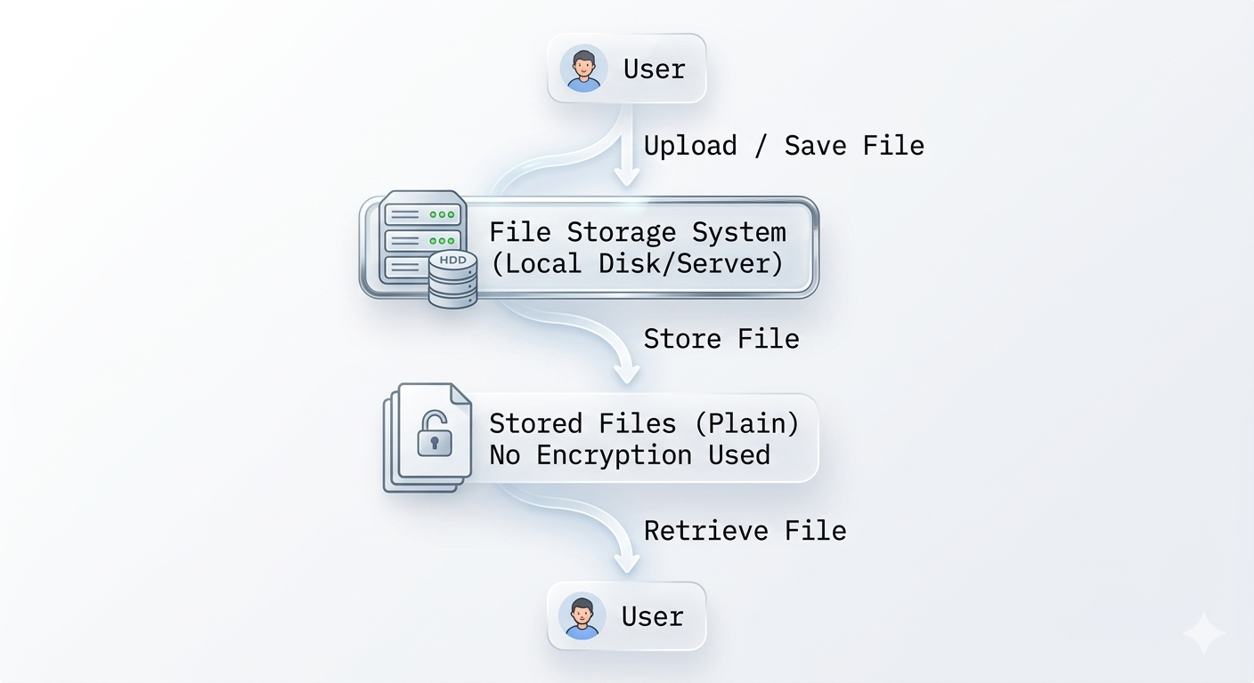
Fig 3.2.1 Dataflow of existing system
3.1.1.1 Weaknesses of the Existing System
The existing file storage system has several limitations that affect the security and reliability of stored information. Some of the major weaknesses include the following:
1. Lack of Data Encryption
Files in the existing system are stored in their original readable format without any form of encryption. This means that if an unauthorized user gains access to the storage device, the files can easily be viewed, copied, or modified. The absence of encryption makes sensitive data highly vulnerable to security breaches.
2. Weak Access Control Mechanisms
The system relies mainly on basic authentication methods such as operating system passwords or user permissions. While these controls may restrict direct access to the system, they do not provide sufficient protection if attackers bypass authentication or gain physical access to the storage device.

3. High Risk of Data Breach and Unauthorised Access
Since files are stored in plaintext and lack additional layers of protection, the system is highly exposed to cyber threats such as malware attacks, hacking, and insider misuse. Once access to the storage medium is obtained, attackers can easily retrieve sensitive information.

3.1.2 Analysis of the Proposed System
The proposed secure file storage system improves the security and management of stored files by integrating encryption and controlled access mechanisms. The major advantages of the proposed system include the following:
1. Enhanced Data Security Through Encryption
The proposed system encrypts files before storage using the Advanced Encryption Standard (AES). This ensures that even if unauthorised users gain access to the storage device, the files remain unreadable without the correct decryption key.
2. Improved Access Control
The system incorporates authentication mechanisms that ensure only authorized users can upload, access, or retrieve files. This reduces the risk of unauthorized access and enhances overall system security.
3. Better Protection Against Data Breaches
Since files are stored in encrypted form, the impact of potential data breaches is significantly reduced. Even if attackers obtain the stored files, they cannot interpret the encrypted data without the appropriate decryption credentials.

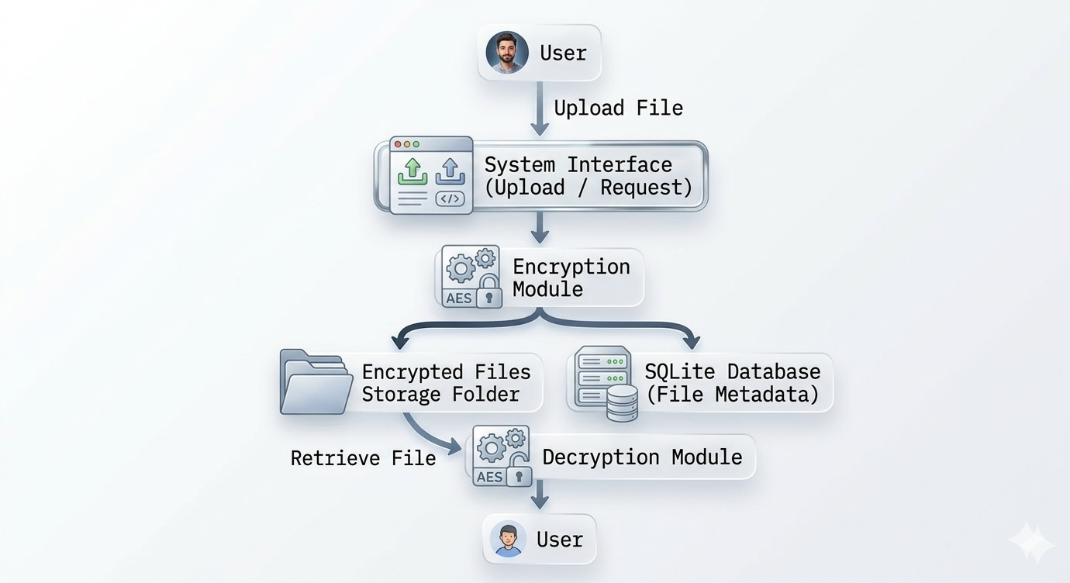
Fig 3.2.1 Dataflow of Diagram of the Proposed System

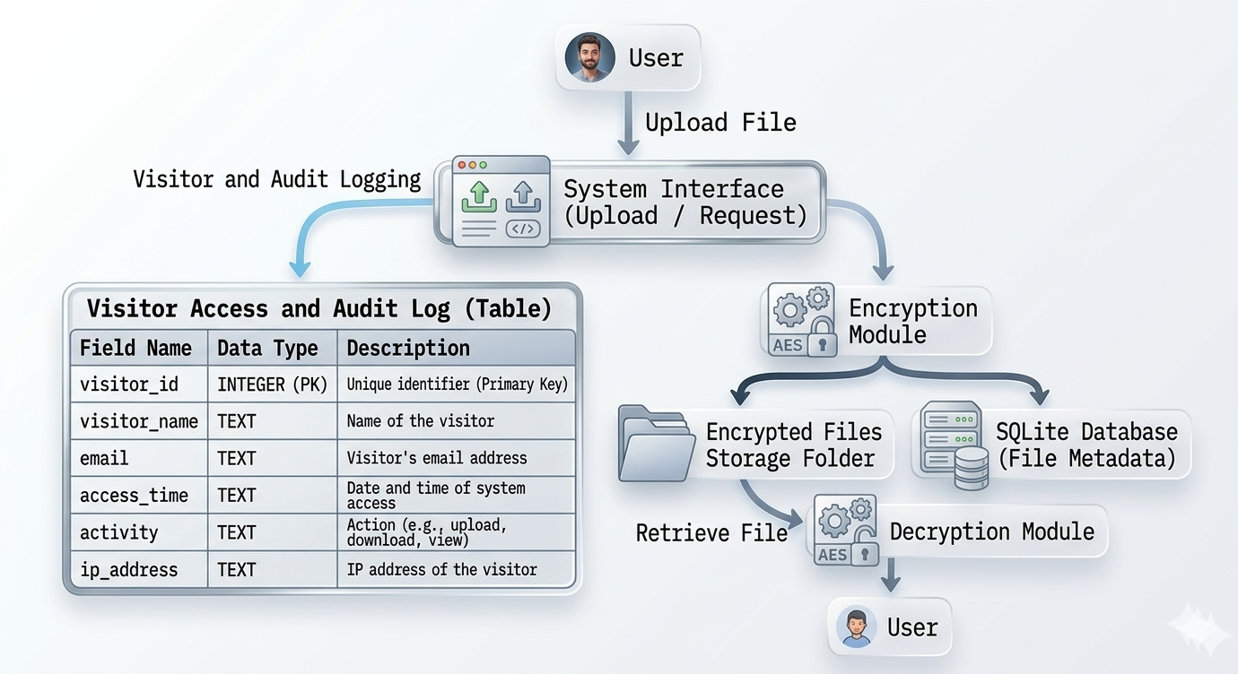
Fig 3.2.1 Dataflow of Visitors Table and Table Diagram of the Proposed System

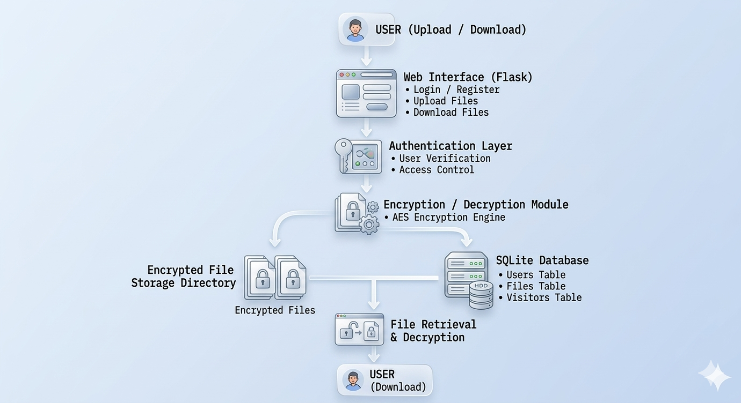
Fig 3.2.1 System Architecture

3.1.2.1 Advantages of the Proposed System
- Enhanced Data Security: Files are encrypted using the Advanced Encryption Standard (AES) before storage, ensuring confidentiality even if unauthorised access occurs.
- Controlled Access: Only authenticated users can upload, download, or retrieve files, reducing the risk of unauthorised access.
- Protection Against Data Breaches: Encrypted files cannot be interpreted without the correct decryption key, minimising the impact of potential breaches.
- Efficient File Management: Metadata stored in SQLite allows easy tracking, retrieval, and management of stored files.
- Cost-Effective and Lightweight: Utilises open-source tools such as Python, Flask, and SQLite, making it affordable and straightforward to implement for individuals and small organisations.

3.1.2.3 High-Level Model of the Proposed System
The high-level model of the proposed system outlines the overall structure and interactions between its major components.
The system consists of four primary components: the user interface, the encryption/decryption module, the secure file storage directory, and the metadata database.
The user interface allows users to upload files for encryption and request decryption when needed. When a file is uploaded, the system processes it through the encryption module, which applies AES encryption to convert the file into ciphertext.
The encrypted file is then stored in a secure directory on the system, ensuring that the stored content cannot be read without proper decryption. At the same time, file metadata such as the encrypted file name, upload date, and encryption parameters are stored in the SQLite database.
When a user requests access to a stored file, the system retrieves the encrypted file and performs decryption using the correct key. The decrypted file is then made available to the user.

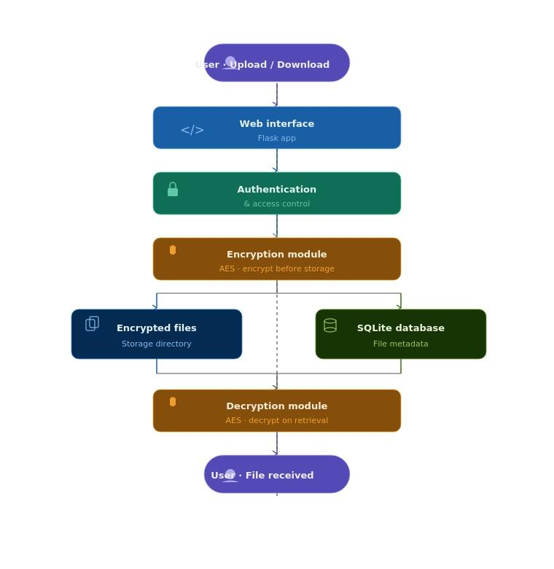

Fig 3.2.2.3 High-Level Model of the Proposed System

3.2 Methodology Adopted
This study adopts the Prototyping Model as the software development methodology for the design and implementation of the secure file storage system. The prototyping approach is suitable for this study because it supports iterative development, allowing the system to be gradually built, tested, and refined based on continuous feedback. This ensures that system requirements are clearly understood and validated before full-scale implementation.
The methodology follows a series of structured stages. The first stage involves requirement analysis, where existing file storage methods and their associated security challenges are examined to identify system needs. This is followed by the system design phase, which outlines the overall architecture of the proposed system, including data flow, system components, and security mechanisms.
Subsequently, a functional prototype of the system is developed using appropriate programming tools and cryptographic libraries. This prototype enables early testing and evaluation of system functionalities, allowing for necessary adjustments and improvements before final implementation.
The system incorporates encryption mechanisms based on the Advanced Encryption Standard (AES) to ensure that files are securely encrypted before storage and only decrypted upon authorised access. A lightweight relational database, SQLite, is used to manage file metadata, while encrypted files are stored within a secure directory structure.
Through the adoption of the Prototyping Model, the system effectively demonstrates how strong cryptographic techniques can be integrated into a practical file storage solution, thereby enhancing data confidentiality and reducing the risk of unauthorised access.

Chapter Four

System Design and Implementation

4.1 Objectives of the New System
The new system, PRECINCT, is a self-hosted secure file-storage web application. It allows a registered user to upload, store, retrieve and delete personal files that are automatically encrypted before being written to storage, so that the raw contents can never be read directly from the server. Unlike a conventional public cloud service, the entire system runs locally on the organisation's own server, meaning all data remains within the organisation's premises and under its control.
The specific objectives of the new system are:
- To provide a secure, password-protected repository where each user can store personal files privately.
- To guarantee data confidentiality by encrypting every uploaded file using strong cryptography (AES via Fernet) so that files are unreadable even to anyone with direct access to the server disk.
- To enforce strong access control through a combination of a hashed password and Two-Factor Authentication (2FA) using a Time-based One-Time Password (TOTP).
- To isolate each user's data so that no user can view, download or delete another user's files.
- To provide an administrative control centre for managing users, contact enquiries and newsletter subscribers.
- To enforce fair storage usage through per-file and per-user storage limits.
- To operate entirely on the local network (on-premises), with the server acting as the organisation's private "cloud".

4.2 Main Menu (Control Centre)
The control centre of the system is presented through a top navigation bar that appears on every page, together with two role-specific dashboards. The navigation adapts to the current user's authentication state and privilege level. The main menu therefore acts as the master routing point from which every subsystem is reached.
Menu Option | Route | Availability | Function
Home | / | All visitors | Landing page / entry point
About | /about | All visitors | Information about the system
Contact | /contact | All visitors | Send an enquiry message
Register | /register | Guests only | Create a new account
Login | /login | Guests only | Authenticate into the system
Dashboard (Vault) | /dashboard | Logged-in users | Personal file management
Admin Console | /admin | Administrators only | System administration
Logout | /logout | Logged-in users | End the session securely
Table 4.1: Main menu (control centre) options
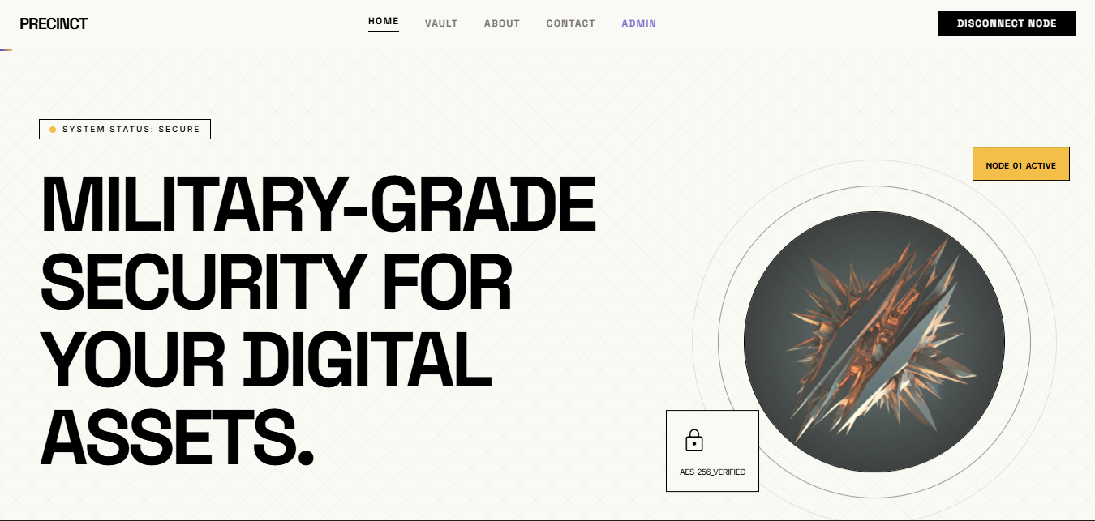
Figure 4.1: The main menu/control centre.

4.3 Sub Menu / Sub System
The system is organised into three logical subsystems. Each subsystem groups together the pages and operations that serve a common purpose.

4.3.1 Public / Marketing Subsystem
Accessible to every visitor without logging in. It comprises the Home page, the About page, the Contact form (which stores enquiries in the database) and the Newsletter subscription feature.

4.3.2 Authentication Subsystem
Handles identity and access. It comprises registration, Two-Factor Authentication (2FA) setup with a scannable QR code, login (password verification) and 2FA code verification, and logout. A user cannot reach the vault until both the password and a valid 2FA code have been supplied.

4.3.3 User Vault Subsystem
The private area for an authenticated user. It comprises the Dashboard (which lists the user's files and shows a live storage-usage bar), file Upload (with automatic encryption), file Download (with automatic decryption) and permanent file Delete.

4.3.4 Administrative Subsystem
Available only to users flagged as administrators. It comprises the Operators panel (promote/demote administrators), the Contact-messages panel (view/delete enquiries) and the Newsletter-subscribers panel.
Subsystem | Operations | Access Level
Public / Marketing | Home, About, Contact, Subscribe | Everyone
Authentication | Register, Setup 2FA, Login, Verify 2FA, Logout | Guests
User Vault | Dashboard, Upload, Download, Delete | Registered users
Administration | Manage operators, Manage messages, View subscribers | Administrators

Table 4.2: Subsystems and their operations

4.4 Database Specifications
The system uses a relational SQLite database (file instance/site.db) managed through the Flask-SQLAlchemy Object-Relational Mapper. It contains four tables. The file table has a many-to-one relationship with the user table (one user owns many files).
Field | Data Type | Constraint | Description
id | Integer | Primary Key | Unique user identifier
username | String(20) | Unique, Not Null | Login name
password_hash | String(60) | Not Null | Bcrypt hash of the password (never the plain password)
totp_secret | String(32) | Nullable | Secret key used to generate/verify 2FA codes
is_admin | Boolean | Not Null, default False | Whether the user has admin rights
Table 4.3: USER table

Field | Data Type | Constraint | Description
id | String(36) | Primary Key | UUID; also the stored filename
user_id | Integer | Foreign Key → user.id, Not Null | Owner of the file
filename | String(255) | Not Null | Encrypted file name on disk (e.g. <uuid>.enc)
original_filename | String(255) | Not Null | Real name shown to the user (e.g. report.pdf)
upload_date | DateTime | Not Null, default now | Time of upload
file_size | Integer | Not Null | Original size in bytes (for quota calculation)
Table 4.4: FILE table

Field | Data Type | Constraint | Description
id | Integer | Primary Key | Message identifier
name | String(100) | Not Null | Sender's name
email | String(120) | Not Null | Sender's email
message | Text | Not Null | Message body
submitted_at | DateTime | Not Null, default now | Time submitted
Table 4.5: CONTACT_MESSAGE table

Field | Data Type | Constraint | Description
id | Integer | Primary Key | Subscriber identifier
email | String(120) | Unique, Not Null | Subscriber's email
subscribed_at | DateTime | Not Null, default now | Time subscribed

Table 4.6: NEWSLETTER_SUBSCRIBER table

4.5 Program Module Specification
The program is divided into cooperating modules, each with a single responsibility. This modular design makes the system easier to maintain and test.
Module (File) | Responsibility | Key Functions / Contents
app.py | Application factory & configuration | Creates the Flask app, configures the database and upload folder, registers the routes, creates tables on start-up.
models.py | Data layer | Defines User, File, ContactMessage, NewsletterSubscriber tables and initialises the database, bcrypt and login manager.
routes.py | Application logic / controllers | Handles every URL: registration, 2FA, login, dashboard, upload, download, delete, admin actions.
crypto_util.py | Cryptography helper | derive_key() (PBKDF2 key derivation), encrypt_file_data(), decrypt_file_data() (Fernet/AES).
make_admin.py | Administration utility | Command-line tool to list users and grant/revoke admin rights.
app/templates/ | Presentation layer | Jinja2 HTML pages (index, register, login, dashboard, admin, etc.).

Table 4.7: Program modules

4.5.1 Key routine specifications
- register() — validates the username is unique, hashes the password with bcrypt, generates a TOTP secret, makes the first-ever user an admin, then routes to 2FA setup.
- login() / verify_2fa() — checks the password against the bcrypt hash, derives the file-encryption key from the password, and then requires a valid 6-digit TOTP code before granting the session.
- upload() — enforces the 10 MB file limit and 100 MB user quota, encrypts the file, stores it as <uuid>.enc, and records its metadata.
- download() — verifies ownership, reads the encrypted file, decrypts it in memory, and returns it under its original name.

4.6 Input and Output Specification
The tables below describe the principal inputs the system accepts and the outputs it produces.
Input | Source | Fields / Format
Registration data | Registration form | Username (text), Password (text)
2FA code | Verify-2FA form | 6-digit numeric code from authenticator app
Login credentials | Login form | Username, Password
File to store | Upload form | Any file, maximum 10 MB
Contact enquiry | Contact form | Name, Email, Message
Newsletter email | Subscribe form | Email address
Table 4.8: Input specification

Output | Destination | Format / Content
2FA QR code | Setup page | Scannable image + secret key
File list & storage usage | Dashboard | Table of files + percentage-used bar
Decrypted file | Download | Original file returned to the user
Encrypted file | Server disk | <uuid>.enc in uploads/
Status messages | Every page | Success / error "flash" notifications
Admin listings | Admin console | Users, messages, subscribers

Table 4.9: Output specification

4.7 Overall Data Flow Diagram of the New System
Figure 4.3 shows the overall flow of data between the user, the processing logic, the encryption module and the two storage areas (the database and the encrypted file store).
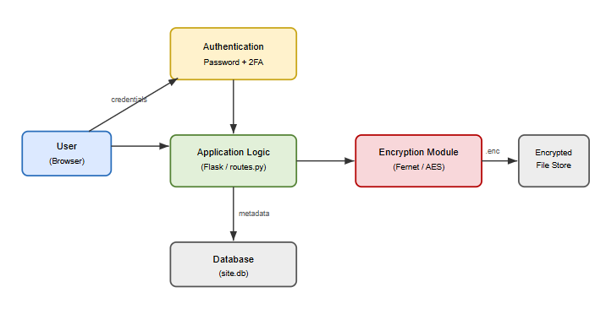
Figure 4.3: Overall data-flow diagram of the PRECINCT system
The user's raw file never reaches storage in plain form: it flows through the application logic into the encryption module, and only the encrypted (.enc) version is written to the file store, while its metadata (owner, name, size) is written to the database.

4.8 Program Flowcharts

4.8.1 Login and Two-Factor Authentication Flowchart
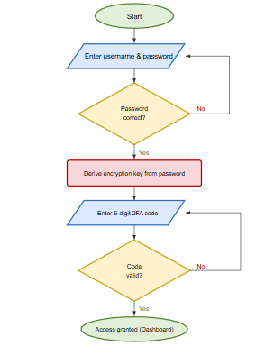
Figure 4.4: Login and 2FA authentication flowchart

4.8.2 File Upload (Encryption) Flowchart
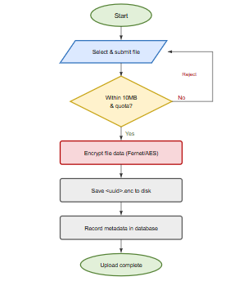
Figure 4.5: File upload and encryption flowchart

4.9 Program Documentation and Implementation
The system was implemented using the Python programming language with the Flask web framework, following a layered (Model–View–Controller-like) architecture:
- Model layer — models.py defines the database tables using SQLAlchemy.
- View layer — the Jinja2 HTML templates in app/templates/ render the interface.
- Controller layer — routes.py receives requests, applies the business rules, and returns the appropriate view.
- Security layer — crypto_util.py performs key derivation and file encryption/decryption.
To implement (install and run) the system on a machine, the following steps are performed from the project folder:
- Install Python 3.
- Install the required libraries: pip install -r requirements.txt.
- Start the server: python app.py. On first run the database and upload folder are created automatically.
- Open a browser at http://127.0.0.1:5000. The first account registered automatically becomes the administrator.
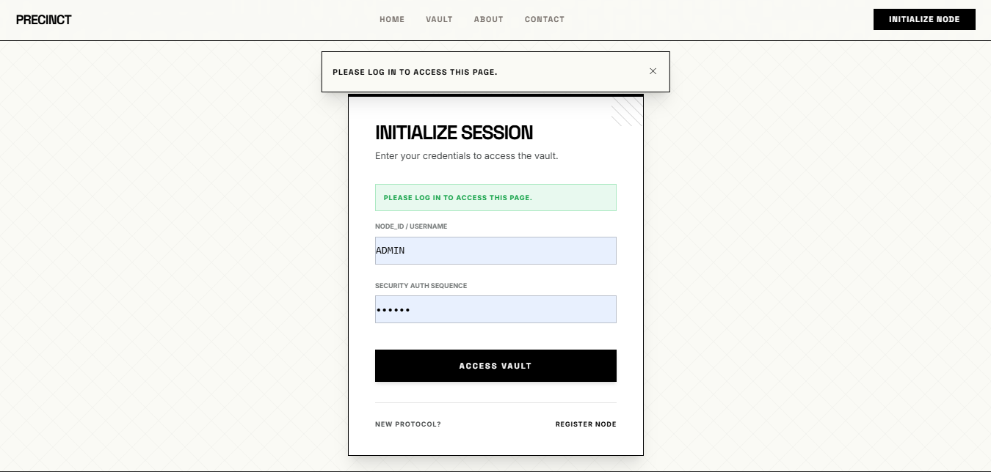
Figure 4.6 Registration Page
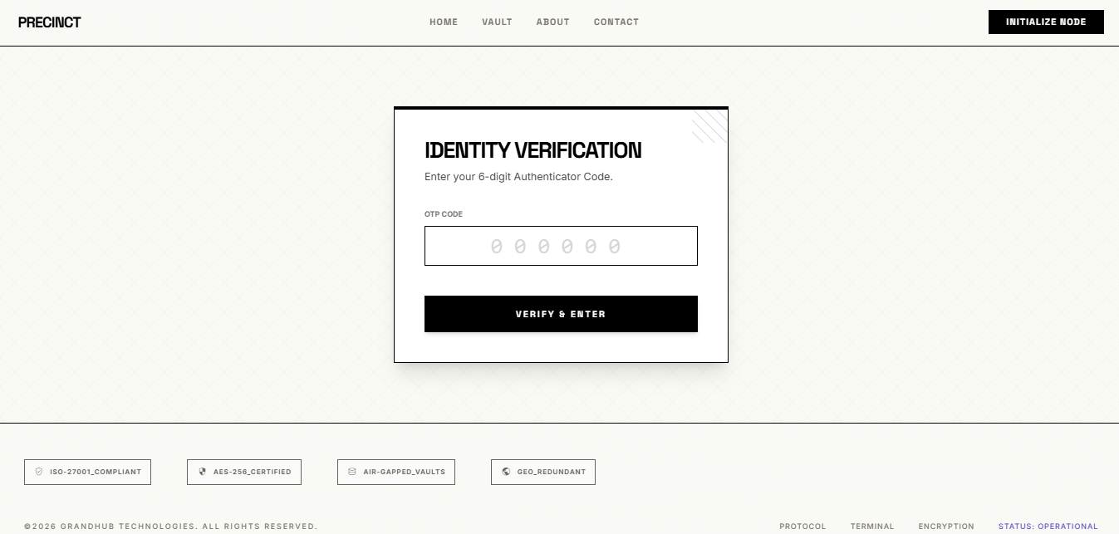
Figure 4.7 Registration Page

4.10 Language / Software Justification
The choice of tools for this project was guided by security, reliability and the requirement to run entirely on a local server. The justification is summarised below.
Tool | Justification
Python 3 | Simple, readable, widely taught, and has mature, well-tested security libraries.
Flask | A lightweight web framework, easy to deploy on a local server without heavy configuration.
SQLite | A serverless, file-based database that needs no separate database server, making the system fully self-contained and local.
cryptography (Fernet) | Provides authenticated AES encryption using vetted, industry-standard algorithms rather than home-made cryptography.
Bcrypt | An intentionally slow, salted hashing algorithm that protects passwords against brute-force attacks.
PyOTP | Implements the standard TOTP algorithm, compatible with common authenticator apps (Google Authenticator, etc.).

Table 4.10: Justification of tools used

4.11 Hardware and Operating System Requirements
Component | Minimum Requirement
Processor | Dual-core 1.6 GHz or higher
Memory (RAM) | 2 GB (4 GB recommended)
Storage | 500 MB free space (plus space for stored files)
Network | Local area network (for multi-user access on the server)
Table 4.11: Minimum hardware requirements

Component | Requirement
Operating System | Windows 10/11, Linux, or macOS
Runtime | Python 3.10 or higher
Libraries | Flask, Flask-SQLAlchemy, Flask-Bcrypt, Flask-Login, cryptography, pyotp, qrcode (see requirements.txt)
Client | Any modern web browser (Chrome, Edge, Firefox)
Authenticator | A TOTP app (Google Authenticator, Authy, etc.)

Table 4.11: Software requirements

4.12 Software Testing
The system was tested using the black-box method: each function was exercised with valid and invalid inputs, and the actual result was compared with the expected result. The results are shown below.
# | Test Case | Input | Expected Result | Status
1 | Register with unique username | New username & password | Account created, redirected to 2FA setup | Pass
2 | Register with existing username | Duplicate username | Rejected with "Username is already taken" | Pass
3 | Login with wrong password | Correct user, wrong password | Rejected, access denied | Pass
4 | Login with invalid 2FA code | Correct password, wrong code | Rejected with "Invalid 2FA code" | Pass
5 | Successful login | Correct password + valid code | Access to dashboard granted | Pass
6 | Upload file within limit | File < 10 MB | File encrypted and stored | Pass
7 | Upload oversized file | File > 10 MB | Rejected with size error | Pass
8 | Exceed storage quota | Total > 100 MB | Rejected with quota error | Pass
9 | Download own file | Click download | Original file returned decrypted | Pass
10 | Access another user's file | Different owner's file ID | Rejected with "Unauthorized Access" | Pass
11 | Non-admin opens admin page | Normal user visits /admin | Redirected, access denied | Pass
12 | Remove last admin | Demote the only admin | Blocked with "Cannot remove the last admin" | Pass
Table 4.12: Test cases and results

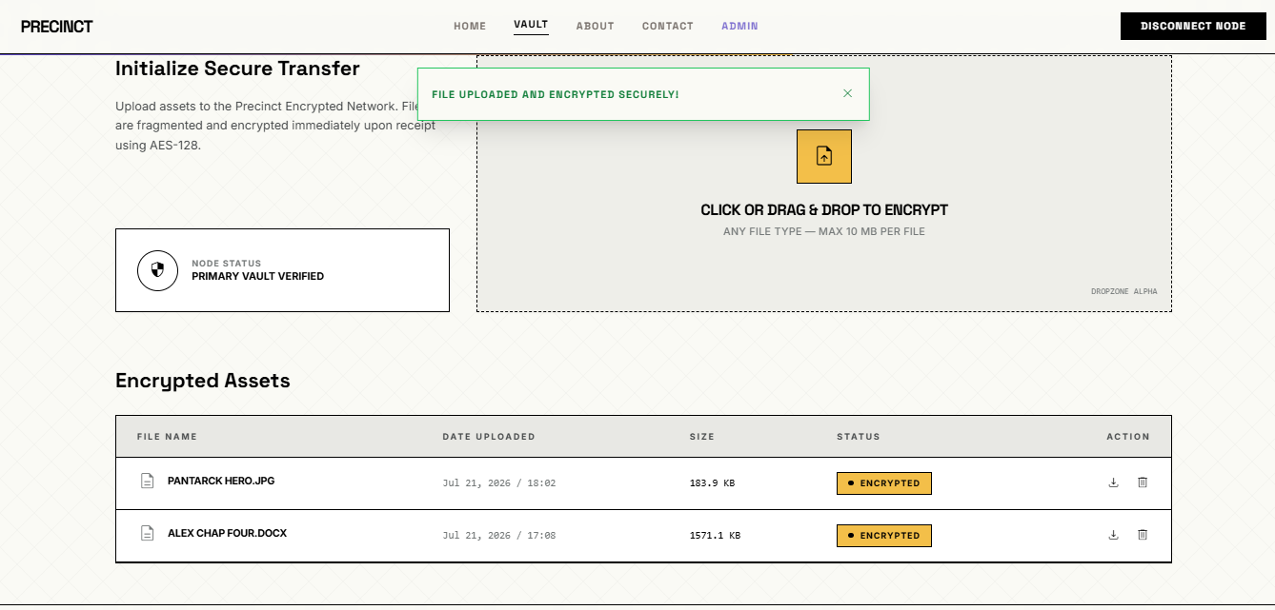

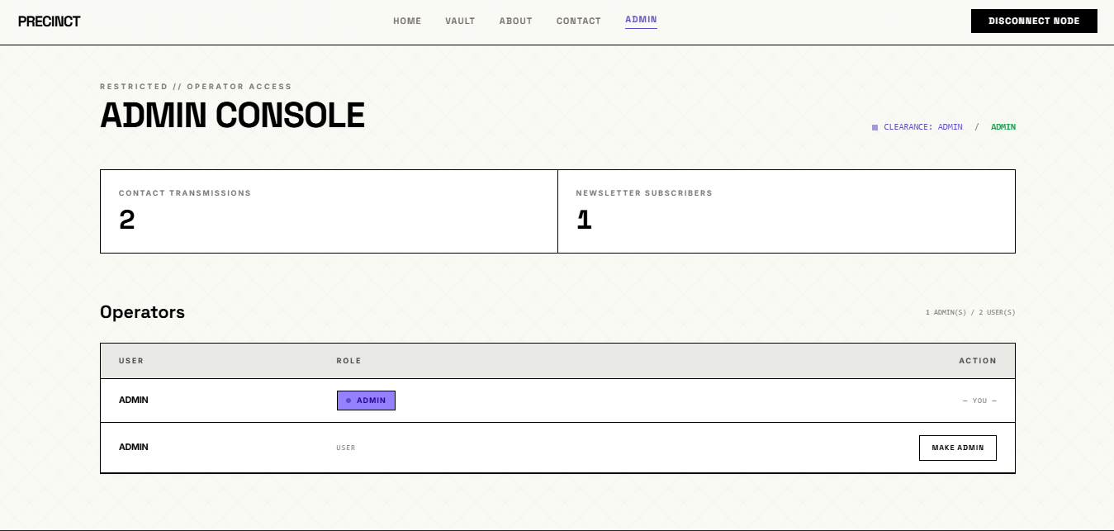

4.13 User Manual
This section guides a new user through operating the PRECINCT system.

4.13.1 Starting the system
- Open the project folder and run python app.py.
- Open a web browser and go to http://127.0.0.1:5000.

4.13.2 Creating an account
- Click Register and enter a username and password.
- On the next screen, open your authenticator app and scan the QR code (or type the secret key).
- Your account is now protected by Two-Factor Authentication.

4.13.3 Logging in
- Click Login and enter your username and password.
- Enter the current 6-digit code from your authenticator app when prompted.
- On success you are taken to your Dashboard (vault).

4.13.4 Managing files
- Upload: choose a file (max 10 MB) and submit; it is encrypted automatically.
- Download: click the download button beside a file to retrieve the original.
- Delete: click delete to permanently remove a file and its encrypted copy.
- The storage bar shows how much of your 100 MB allowance you have used.

4.13.5 Administrator functions
- Log in with an administrator account and open the Admin Console.
- Promote or demote other users (operators), read or delete contact messages, and view newsletter subscribers.

4.13.6 Logging out
Click Logout to end your session securely. Your encryption key is removed from memory, so your files cannot be decrypted until you log in again.

CHAPTER FIVE

SUMMARY AND CONCLUSION

5.1 SUMMARY
This seminar work focused on the development of a secure file storage system designed to mitigate the risks associated with unauthorised data access and cyber threats. The research highlighted that while traditional access control methods like passwords provide a first line of defence, they are often insufficient when storage media is physically or digitally compromised. To address this, the system integrates the Advanced Encryption Standard (AES), a symmetric cryptographic algorithm, to ensure that files remain unreadable to unauthorised parties even if they bypass system authentication. The development followed the Prototyping Model, allowing for iterative refinement and validation of system requirements. The final architecture utilises a secure directory structure for storing encrypted files and a lightweight SQLite database for managing file metadata. By combining strong cryptographic techniques with a user-friendly interface, the project successfully demonstrates a practical approach to enhancing data confidentiality and integrity in modern digital environments.

5.2 CONCLUSION
The implementation of this secure file storage system confirms that encryption is a fundamental necessity for protecting sensitive information in an increasingly volatile digital landscape. Through the systematic application of AES, the study achieved its primary objective of creating a robust security layer that protects data at rest. The transition from unencrypted storage to a cryptographically secured environment significantly reduces the potential impact of data breaches and unauthorised intrusions. Ultimately, this project serves as a proof of concept that integrating industrial-grade encryption standards into localised storage solutions is both feasible and essential.

REFERENCES

Akawuku, G. I., Ikediego, O. H., & Nwankwo, G. C. (2025). Software engineering dimensions: Empirical frameworks on microservices architecture in cloud computing domains. IAA Journals.

Daemen, J., & Rijmen, V. (2002). The design of Rijndael: AES—The Advanced Encryption Standard. Springer.

Dworkin, M. (2007). Recommendation for block cipher modes of operation: Galois/Counter Mode (GCM) and GMAC (NIST Special Publication 800-38D). National Institute of Standards and Technology. https://doi.org/10.6028/NIST.SP.800-38D

Ekwonwune, E. N., Chigozie, U. C., Ekekwe, D. A., & Nwankwo, G. C. (2024). Analysis of secured cloud data storage model for information. Scientific Research Publishing. https://www.researchgate.net/publication/377543210

Ferguson, N., Schneier, B., & Kohno, T. (2010). Cryptography engineering: Design principles and practical applications. Wiley.

Lai, J.-F., & Heng, S.-H. (2022). Secure file storage on cloud using hybrid cryptography. Journal of Informatics and Web Engineering, 1(2). https://doi.org/10.33093/jiwe.2022.1.2.1

M'Raihi, D., Machani, S., Pei, M., & Rydell, J. (2011). TOTP: Time-based one-time password algorithm (RFC 6238). Internet Engineering Task Force. https://doi.org/10.17487/RFC6238

Mata, F., Kimwele, M., & Okeyo, G. (2017). Enhanced secure data storage in cloud computing using hybrid cryptographic techniques (AES and Blowfish). International Journal of Science and Research, 6(3), 1702–1708.

Menezes, A. J., van Oorschot, P. C., & Vanstone, S. A. (1996). Handbook of applied cryptography. CRC Press.

National Institute of Standards and Technology. (2001). Announcing the Advanced Encryption Standard (AES) (FIPS PUB 197). U.S. Department of Commerce. https://nvlpubs.nist.gov/nistpubs/FIPS/NIST.FIPS.197.pdf

Nwankwo, C., Ekwonwune, E. N., & Duroha, A. (2021). Machine learning approaches for predictive threat detection in cybersecurity. International Journal of Advanced Computing. https://www.researchgate.net/publication/351098456

Nwankwo, C., Onyagu, I., & Akawuku, G. I. (2023). Adaptive cybersecurity systems for real-time threat detection. Journal of Emerging Technologies in Computing. https://www.researchgate.net/publication/369874102

OWASP Foundation. (n.d.). File upload cheat sheet. OWASP Cheat Sheet Series. https://cheatsheetseries.owasp.org/cheatsheets/File_Upload_Cheat_Sheet.html

OWASP Foundation. (n.d.). Password storage cheat sheet. OWASP Cheat Sheet Series. https://cheatsheetseries.owasp.org/cheatsheets/Password_Storage_Cheat_Sheet.html

Pallets Projects. (n.d.). Flask documentation. https://flask.palletsprojects.com/

Pallets Projects. (n.d.). Security considerations—Flask documentation. https://flask.palletsprojects.com/en/stable/web-security/

Saginayev, E., Niyazov, A., Razaque, A., Kalpeyeva, Z., & Urazgaliyeva, A. (2024). Secure file storage on cloud using hybrid cryptography. Computing and Engineering, 2. https://doi.org/10.51301/ce.2024.i2.01

APPENDIX A
“SOURCE CODE”
from flask import Blueprint, render_template, url_for, flash, redirect, request, current_app, send_file, session
from flask_login import login_user, current_user, logout_user, login_required
from models import db, bcrypt, User, File, ContactMessage, NewsletterSubscriber
from crypto_util import encrypt_file_data, decrypt_file_data, derive_key
import os
import uuid
import io
import pyotp
import qrcode
import base64

# Storage limits
MAX_FILE_SIZE = 10 * 1024 * 1024 # 10 MB per file
MAX_USER_QUOTA = 100 * 1024 * 1024 # 100 MB per user

main = Blueprint('main', __name__)

@main.route("/")
def index():
return render_template('index.html')

@main.route("/about")
def about():
return render_template('about.html')

@main.route("/contact", methods=['GET', 'POST'])
def contact():
if request.method == 'POST':
name = request.form.get('name', '').strip()
email = request.form.get('email', '').strip()
message = request.form.get('message', '').strip()

if not name or not email or not message:
flash('All fields are required. Transmission incomplete.', 'danger')
return redirect(url_for('main.contact'))

entry = ContactMessage(name=name, email=email, message=message)
db.session.add(entry)
db.session.commit()
flash('Transmission received. We will respond shortly.', 'success')
return redirect(url_for('main.contact'))

return render_template('contact.html')

@main.route("/subscribe", methods=['POST'])
def subscribe():
email = request.form.get('email', '').strip()
if not email:
flash('A valid email is required to subscribe.', 'danger')
return redirect(url_for('main.index') + '#subscribe')

already = NewsletterSubscriber.query.filter_by(email=email).first()
if already:
flash('This node is already subscribed to the network.', 'info')
return redirect(url_for('main.index') + '#subscribe')

subscriber = NewsletterSubscriber(email=email)
db.session.add(subscriber)
db.session.commit()
flash('Access granted. You are now subscribed to PRECINCT protocols.', 'success')
return redirect(url_for('main.index') + '#subscribe')

@main.route("/register", methods=['GET', 'POST'])
def register():
if current_user.is_authenticated:
return redirect(url_for('main.dashboard'))
if request.method == 'POST':
username = request.form.get('username')
password = request.form.get('password')

user_exists = User.query.filter_by(username=username).first()
if user_exists:
flash('Username is already taken.', 'danger')
return redirect(url_for('main.register'))

hashed_password = bcrypt.generate_password_hash(password).decode('utf-8')
totp_secret = pyotp.random_base32()
# The very first account to register becomes the admin.
is_first_user = User.query.count() == 0
user = User(username=username, password_hash=hashed_password,
totp_secret=totp_secret, is_admin=is_first_user)
db.session.add(user)
db.session.commit()

session['setup_2fa_user_id'] = user.id
flash('Account created! Please set up Two-Factor Authentication.', 'success')
return redirect(url_for('main.setup_2fa'))
return render_template('register.html')

@main.route("/setup_2fa")
def setup_2fa():
if current_user.is_authenticated:
return redirect(url_for('main.dashboard'))

user_id = session.get('setup_2fa_user_id')
if not user_id:
return redirect(url_for('main.login'))

user = User.query.get(user_id)
if not user:
return redirect(url_for('main.login'))

totp = pyotp.TOTP(user.totp_secret)
uri = totp.provisioning_uri(name=user.username, issuer_name="PRECINCT")

img = qrcode.make(uri)
buf = io.BytesIO()
img.save(buf)
img_b64 = base64.b64encode(buf.getvalue()).decode('utf-8')

return render_template('setup_2fa.html', secret=user.totp_secret, qr_b64=img_b64)

@main.route("/login", methods=['GET', 'POST'])
def login():
if current_user.is_authenticated:
return redirect(url_for('main.dashboard'))
if request.method == 'POST':
username = request.form.get('username')
password = request.form.get('password')

user = User.query.filter_by(username=username).first()
if user and bcrypt.check_password_hash(user.password_hash, password):
session['pending_user_id'] = user.id
session['encryption_key'] = derive_key(password, user.username)
return redirect(url_for('main.verify_2fa'))
else:
flash('Login Unsuccessful. Please check username and password', 'danger')
return render_template('login.html')

@main.route("/verify_2fa", methods=['GET', 'POST'])
def verify_2fa():
if current_user.is_authenticated:
return redirect(url_for('main.dashboard'))

user_id = session.get('pending_user_id')
if not user_id:
flash('Session expired. Please log in again.', 'warning')
return redirect(url_for('main.login'))

if request.method == 'POST':
code = request.form.get('code')
user = User.query.get(user_id)

totp = pyotp.TOTP(user.totp_secret)
if totp.verify(code):
login_user(user)
session.pop('pending_user_id', None)
flash('Login Successful!', 'success')
next_page = request.args.get('next')
return redirect(next_page) if next_page else redirect(url_for('main.dashboard'))
else:
flash('Invalid 2FA code', 'danger')

return render_template('verify_2fa.html')

@main.route("/logout")
def logout():
session.pop('encryption_key', None)
logout_user()
return redirect(url_for('main.index'))

@main.route("/dashboard")
@login_required
def dashboard():
files = File.query.filter_by(user_id=current_user.id).order_by(File.upload_date.desc()).all()
used_bytes = sum(f.file_size for f in files)
used_mb = round(used_bytes / (1024 * 1024), 2)
total_mb = MAX_USER_QUOTA // (1024 * 1024) # 100
used_pct = min(round((used_bytes / MAX_USER_QUOTA) * 100, 1), 100)
return render_template('dashboard.html', files=files,
used_mb=used_mb, total_mb=total_mb, used_pct=used_pct)

@main.route("/admin")
@login_required
def admin():
if not current_user.is_admin:
flash('Unauthorized. Admin access required.', 'danger')
return redirect(url_for('main.dashboard'))
messages = ContactMessage.query.order_by(ContactMessage.submitted_at.desc()).all()
subscribers = NewsletterSubscriber.query.order_by(NewsletterSubscriber.subscribed_at.desc()).all()
users = User.query.order_by(User.is_admin.desc(), User.username).all()
admin_count = sum(1 for u in users if u.is_admin)
return render_template('admin.html', messages=messages, subscribers=subscribers,
users=users, admin_count=admin_count)

@main.route("/admin/user/<int:user_id>/toggle_admin", methods=['POST'])

